|  |  |  |  |
| --- | --- | --- | --- |
| 1 | | 148,067 | |
| **NUMERO DE FRONTERAS** | | **ENERGIA AGREGADA** | |
|  | | | |
| 425,724,484 | 123 | | 15,642,175 |
| INGRESO 2019 | DÍAS CERTIFICADOS 2019 | | ENERGIA RESPALDADA 2019 |
|  | | | |
| 495,353,187 | 152 | | 17,603,378 |
| INGRESO 2020 | DÍAS CERTIFICADOS 2020 | | ENERGIA RESPALDADA 2020 |
|  | | | |
| 535,395,845 | 155 | | 21,671,956 |
| INGRESO 2021 | DÍAS CERTIFICADOS 2021 | | ENERGIA RESPALDADA 2021 |

**HISTORICO REINTEGRO DDV**

|  |  |  |  |
| --- | --- | --- | --- |
|  | **2019** | **2020** | **2021** |
| **ENE** | - | 89.87 | 47.66 |
| **FEB** | - | 104.96 | 87.06 |
| **MAR** | - | 125.09 | 10.88 |
| **ABR** | - | 2.67 | - |
| **MAY** | - | - | 49.06 |
| **JUN** | - | - | 69.99 |
| **JUL** | 80.5 | 15.24 | 57.63 |
| **AGO** | 89.17 | 34.79 | 58.94 |
| **SEP** | 93.14 | 49.76 | 88.55 |
| **OCT** | 26.61 | 70.37 | 65.62 |
| **NOV** | 81.74 | - | - |
| **DIC** | 54.57 | 2.6 | - |

**Los valores de la tabla están en millones de COP**

**REINTEGRO MECANISMO DDV OCTUBRE 2021**

|  |  |  |  |  |  |
| --- | --- | --- | --- | --- | --- |
| FECHA | TIPO DIA | CANTIDADES RESPALDO | PRECIO PONDERADO USD | TRM | PNETO |
| 2021-10-01 | Viernes | 134,435 | 9.0 | 3,784.44 | 4,102,650 |
| 2021-10-02 | Sábado | 134,811 | 9.0 | 3,784.44 | 4,114,125 |
| 2021-10-03 | Domingo - Festivo | 132,801 | 9.0 | 3,784.44 | 4,052,784 |
| 2021-10-04 | Lunes | 135,243 | 9.0 | 3,784.44 | 4,127,309 |
| 2021-10-05 | Martes | 135,227 | 9.0 | 3,784.44 | 4,126,820 |
| 2021-10-06 | Miércoles | 134,310 | 9.0 | 3,784.44 | 4,098,836 |
| 2021-10-07 | Jueves | 133,667 | 9.0 | 3,784.44 | 4,079,213 |
| 2021-10-09 | Sábado | 134,819 | 9.0 | 3,784.44 | 4,114,369 |
| 2021-10-11 | Lunes | 135,251 | 9.0 | 3,784.44 | 4,127,553 |
| 2021-10-13 | Miércoles | 134,310 | 9.0 | 3,784.44 | 4,098,836 |
| 2021-10-15 | Viernes | 134,431 | 9.0 | 3,784.44 | 4,102,528 |
| 2021-10-18 | Domingo - Festivo | 132,823 | 9.0 | 3,784.44 | 4,053,456 |
| 2021-10-19 | Martes | 135,227 | 9.0 | 3,784.44 | 4,126,820 |
| 2021-10-23 | Sábado | 134,814 | 9.0 | 3,784.44 | 4,114,216 |
| 2021-10-24 | Domingo - Festivo | 132,823 | 9.0 | 3,784.44 | 4,053,456 |
| 2021-10-25 | Lunes | 135,247 | 9.0 | 3,784.44 | 4,127,431 |

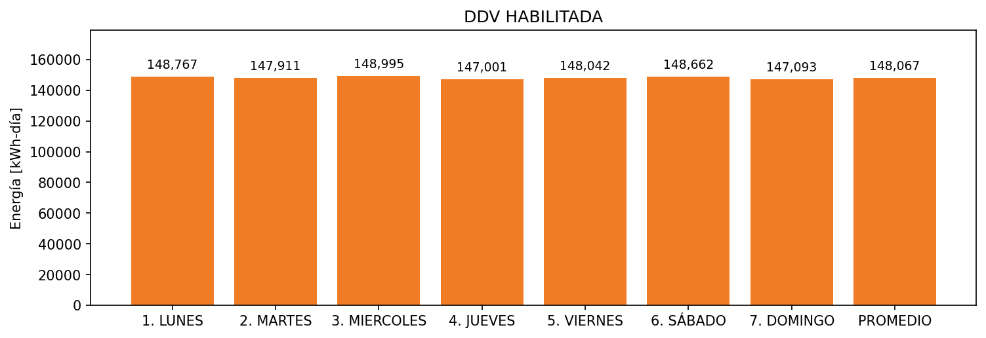

|  |  |  |  |  |  |  |  |  |  |
| --- | --- | --- | --- | --- | --- | --- | --- | --- | --- |
| **FRONTERA** | **COD SIC** | **FRT DDV** | **TIPO DDV** | **PROMEDIO** | **PRÓXIMA ACTUALIZACIÓN** | **MARGEN DE ERROR** | **ÚLTIMA PRUEBA DDV** | **DÍAS PARTICIPACIÓN** | **FECHA REFERENCIA PRÓXIMA PRUEBA DDV** |
| HILANDERIAS UNIVERSAL S.A | Frt00675 | Frt33264 | LBC | 148,067 | 2022-02-10 | 1,51 | 2021-06-30 | 74.0 | 2021-12-20 |